Given the coordinates of two **rectilinear** rectangles in a 2D plane, return *the total area covered by the two rectangles*.

The first rectangle is defined by its **bottom-left** corner (ax1, ay1) and its **top-right** corner (ax2, ay2).

The second rectangle is defined by its **bottom-left** corner (bx1, by1) and its **top-right** corner (bx2, by2).

**Example 1:**

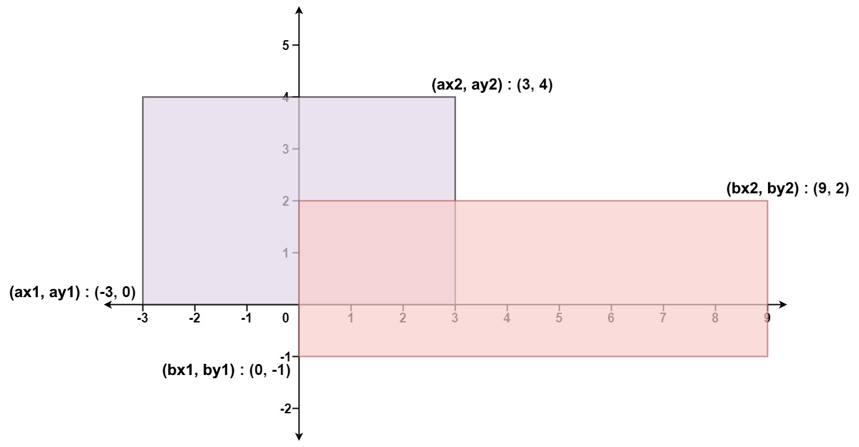

Input: ax1 = -3, ay1 = 0, ax2 = 3, ay2 = 4, bx1 = 0, by1 = -1, bx2 = 9, by2 = 2  
Output: 45

**Example 2:**

Input: ax1 = -2, ay1 = -2, ax2 = 2, ay2 = 2, bx1 = -2, by1 = -2, bx2 = 2, by2 = 2  
Output: 16

**Constraints:**

* -104 <= ax1 <= ax2 <= 104
* -104 <= ay1 <= ay2 <= 104
* -104 <= bx1 <= bx2 <= 104
* -104 <= by1 <= by2 <= 104